PUBLISHING TO GITHUB

i. Why this matters
Christopher Bienko (AI Enablement GTM Product Manager) provides an overview of the Publishing to GitHub module for the hands-on enablement. [2 min]
The finance dashboard from Part 1 | Build runs, passes its validation gates, and is ready to share. But it still lives only inside your IDE workspace. In fact, the workspace is not yet even a git repository — initialization has never occurred, not a single commit exists, and no .gitignore is present to keep dependencies and build artifacts out of version control. Until the code reaches a shared repository, there is no collaborative workspace for issues to capture requirements, for pull requests to carry review, or for continuous integration (CI) to guard the main branch.
Modern delivery treats GitHub as that workspace. An issue is opened, a branch is created, code is written, tests run, a pull request is reviewed, and something is merged. Part 2 of this hands-on lab places IBM Bob inside that loop. Before Bob can fetch an issue or prepare a pull request, however, the repository has to exist in two places: locally as an initialized git repository, and on GitHub.com as the shared remote.
PUBLISH TO YOUR OWN GITHUB REPOSITORIES
A personal GitHub.com account is required for this module and the rest of Part 2 | Evolve.
If your personal GitHub account is already linked to the IBM GitHub enterprise account, you can still publish code to repositories under your own (personal) account. However, you will encounter restrictions on what you can commit and publish to the IBM GitHub repositories — as only approved contributors are able to commit to such endpoints.
To publish code for the purposes of Part 2 | Evolve, you will need to ensure that code is committed via your personal repositories, not the IBM repositories. The repository can be public or private. Bob's workflow is identical either way.
In this module, you will:
- Create the GitHub repository, so the remote exists before anything is pushed to it
- Let Bob inspect the workspace and surface anything blocking a clean push
- Initialize the local repository, putting the Part 1 code under version control
- Publish the code, using the commands Bob prepares
- Enable the collaboration features the rest of Part 2 depends on
- Open the issue that drives the next enhancement
Pay attention to how Bob participates even in this administrative phase. It inspects the working tree, catches blockers like a missing .gitignore, and prepares the exact commands, while you retain control of the actual push.
AI MATURITY CURVE
This module applies the Scale & Extend stage of the AI Maturity Curve to the delivery platform itself. Bob's reach now extends beyond the IDE — inspecting the working tree, surfacing blockers, and preparing the exact commands — while the one action that publishes the work, the push, remains yours to perform. As you learned throughout the previous course, extending an agent's reach and retaining control over consequential actions are practiced together, and this chapter asks you to do exactly that.

ii. Publishing to GitHub
You will move through this module in four phases, in this order:
- Create the empty repository on GitHub.com (steps 1 and 2), so the remote URL exists before anything else.
- Let Bob check readiness and produce the delivery artifacts (steps 3 and 4).
- Initialize the local repository and push (steps 5 through 7).
- Verify and stage the collaboration surface (steps 8 through 10): confirm the publish, enable Issues, create the feature branch, and open the enhancement issue the next module builds on.

- Create the repository on GitHub first, so you have a remote URL to push to later. In your browser, go to GitHub and click New next to Top repositories on the dashboard, or navigate directly to https://github.com/new.
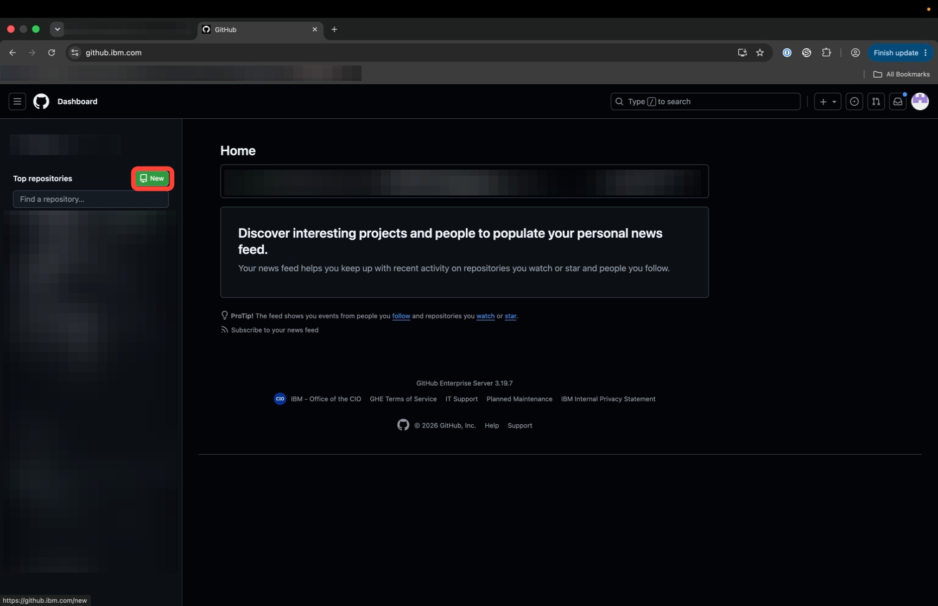
On the Create a new repository form, click the Repository name field and enter finance-app (or your preferred name).
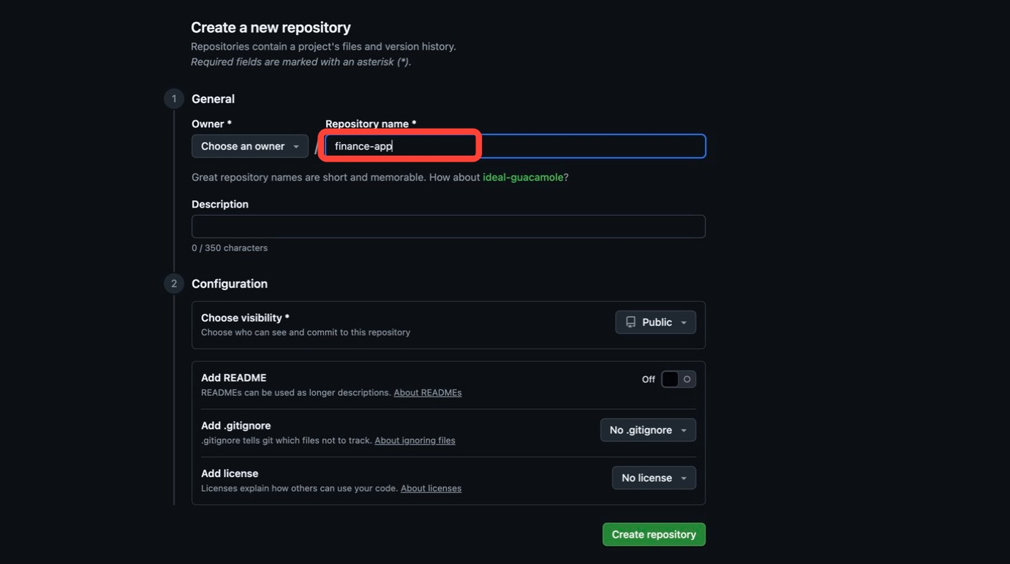
In the Description field, paste IBM Bob Workshop Finance Dashboard Application.
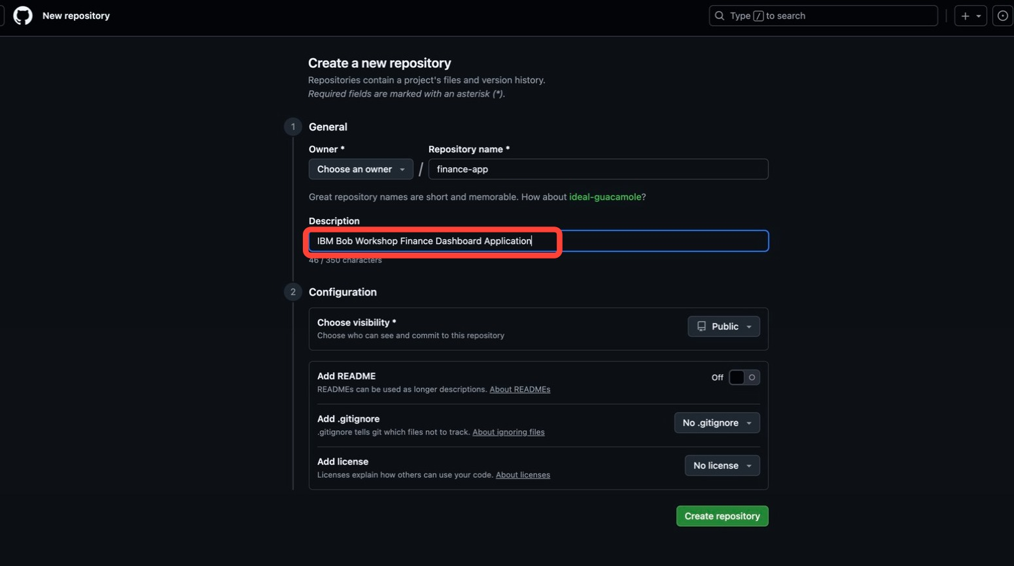
Under Configuration, select a visibility. Public or Private is your choice; Private was used here.
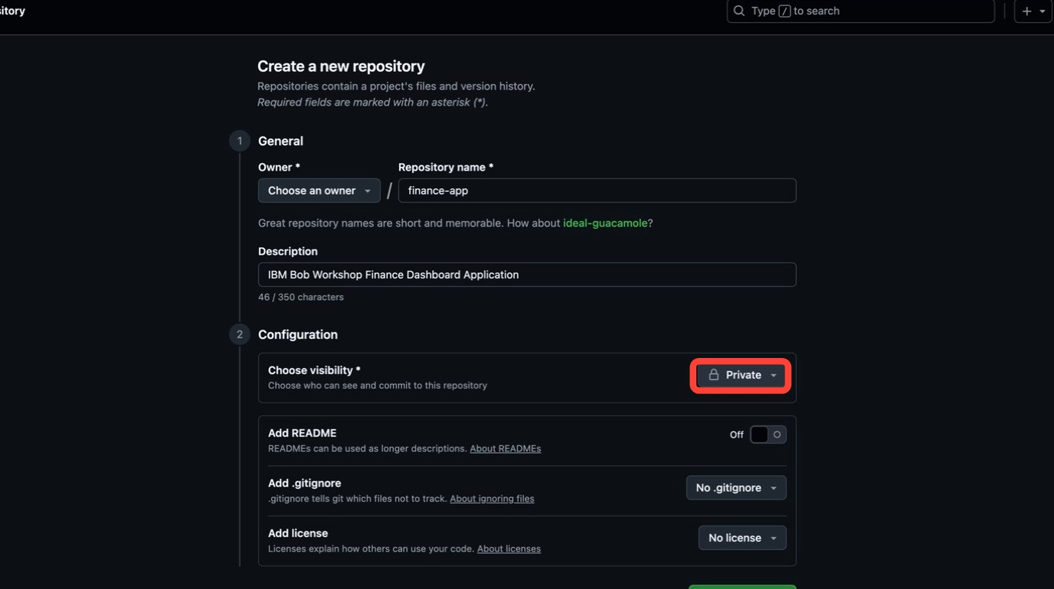
Confirm Add README is toggled Off, and leave Add .gitignore on No .gitignore and Add license on No license. The repository must stay empty because you are pushing existing code. Then click Create repository.
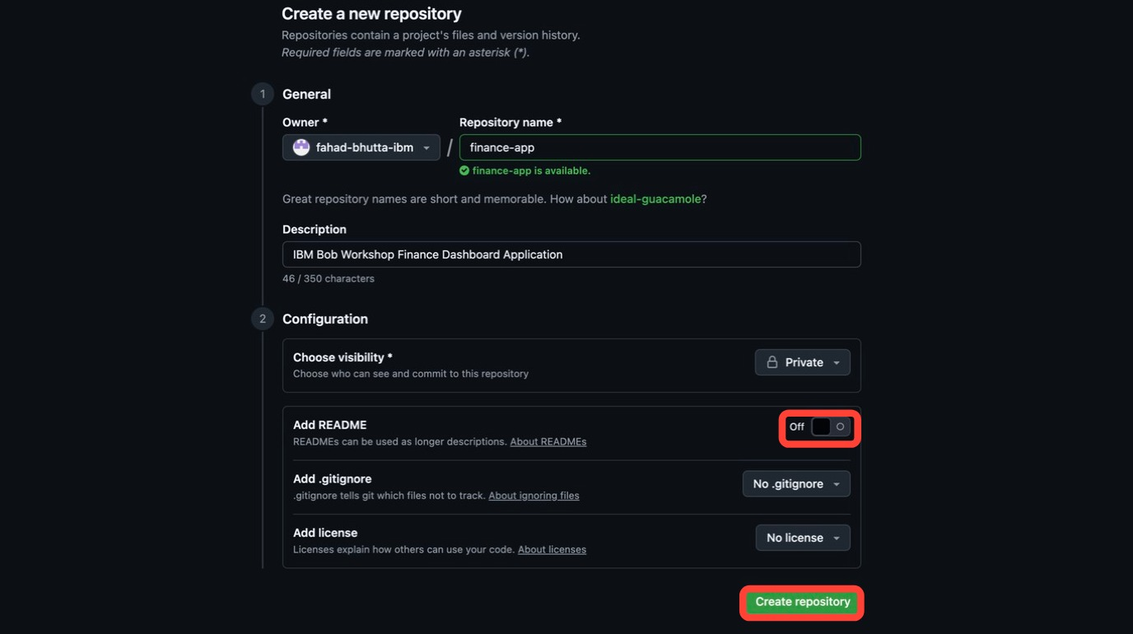

- GitHub will land on the Quick setup page showing the repository's remote URL, in the form https://github.com/YOUR_USERNAME/finance-app.git
Copy and store it within a notepad for now, as you will later need to paste it into a git command in Step 6.
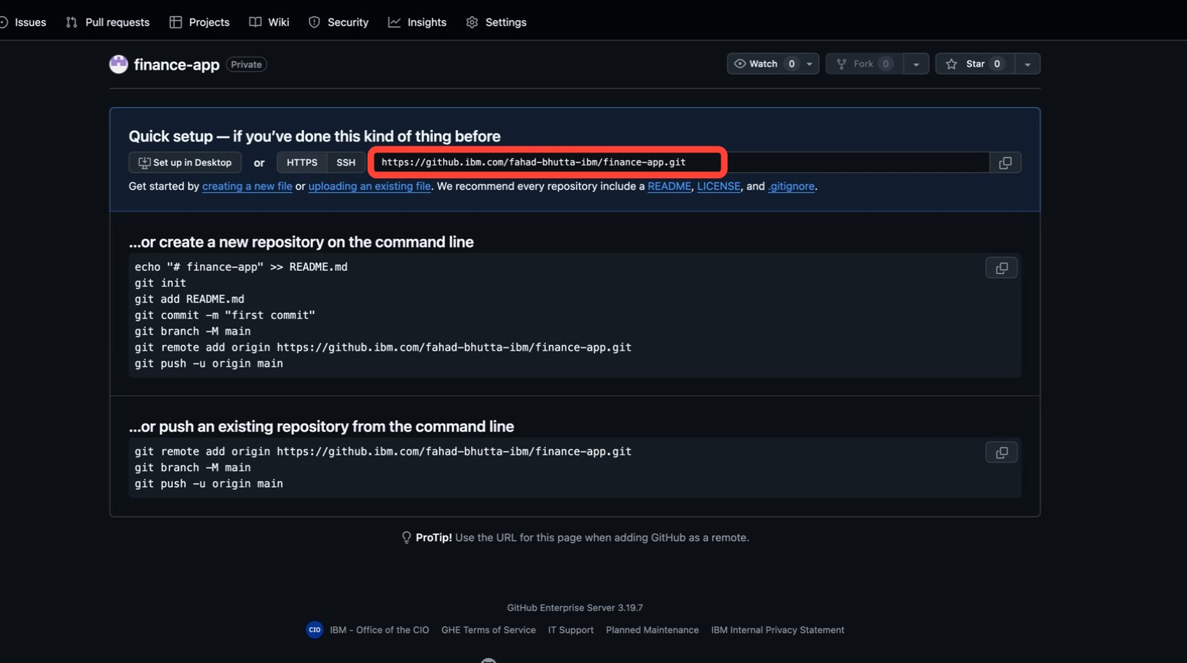

- Now let Bob assess the workspace. Back in the Bob IDE, with Agent mode active, copy and paste the following prompt into the Agentic Sidebar:
- Inspect the current repository changes, summarize the current implementation status of the finance dashboard, and identify whether the project is ready to be committed and pushed to GitHub.
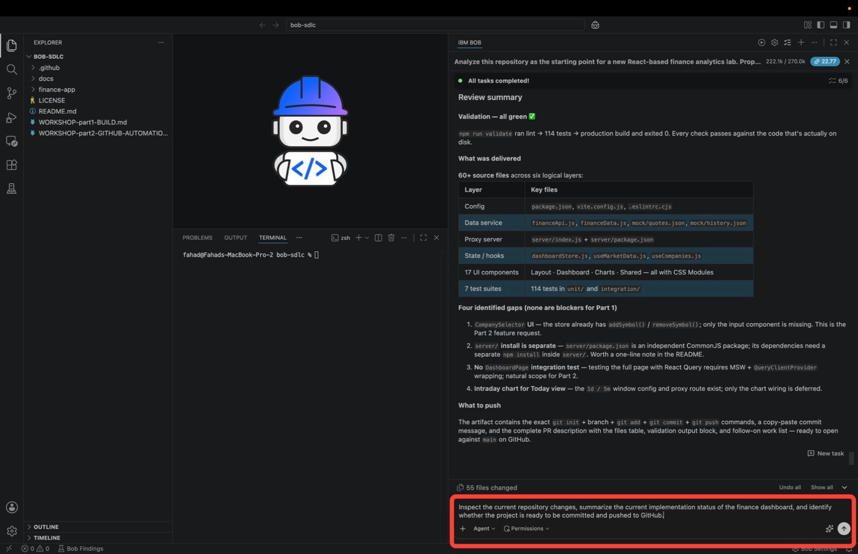
Hit Enter or press the Send button to submit the task.
Bob will begin calling tools to inspect the repository, and will pause for approval before the first one. The command it proposes is read-only, a look at recent history such as git log --oneline -10. Click Approve once to let it run.
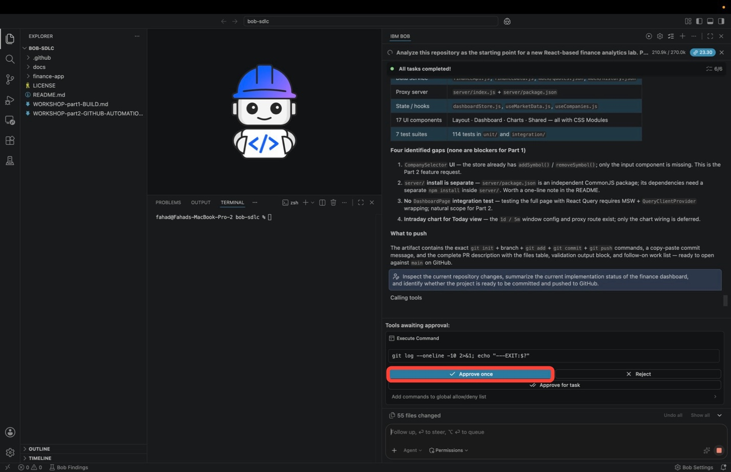
Bob works through the Todo List pinned at the top of the session as it inspects. This is the same validation Todo List Bob completed at the end of Part 1 | Build, now showing 6/6 with every item green, and it is the baseline Bob is assessing for delivery readiness:
TASK | OBJECTIVES
Sub-Task 1 | Fix the dev:mock script environment variable (USE_MOCK → VITE_USE_MOCK) and add the validate and test:coverage scripts
Sub-Task 2 | Extend formatters.test.js with formatVolume, formatIndex, and formatAxisDate suites
Sub-Task 3 | Add PerformanceBadge.test.jsx covering rendering and the positive, negative, and null states
Sub-Task 4 | Add RankingStrip.test.jsx covering sort order, all symbols rendered, null-percentage safety, and price display
Sub-Task 5 | Add WeekChangeSummary.test.jsx covering the chip per symbol, start and end prices, and the empty guard
Sub-Task 6 | Run the full validation suite and confirm all checks pass
Bob reruns the validation suite against the code on disk, explores the source folders, then checks what git would exclude. It finds no root-level .gitignore, meaning node_modules/, dist/, and .DS_Store would all be committed, and may try to create the file itself.
Rather than approving each remaining inspection command one at a time, click Approve for task so Bob can finish the assessment without stopping at every read-only command.
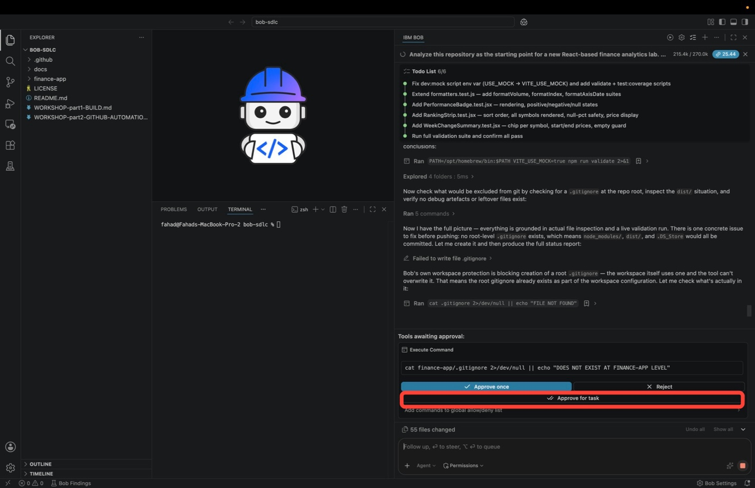
IF BOB CANNOT WRITE THE .gitignore
Bob may report Failed to write file .gitignore because the workspace's own protection blocks writes to a root-level gitignore. This is not a problem. Step 5 below creates the file from the terminal instead.
Bob will inspect the workspace and report two kinds of findings:
  - Code readiness: Bob reruns the validation gates and reports the results, for example npm run lint with zero errors, the full test suite passing, and a clean build.
  - Delivery blockers: expect Bob to point out that the workspace is not yet a git repository (commands like git status return fatal: not a git repository) and that no .gitignore exists, which means node_modules/ (thousands of files) and dist/ would be committed. This is normal. Part 1 never initialized version control, and steps 5 through 7 below fix both findings.
When the assessment finishes, Bob produces the delivery artifact: a numbered, copy-paste sequence of the exact git commands for the push, ending with a staging check, the commit, and the push itself.
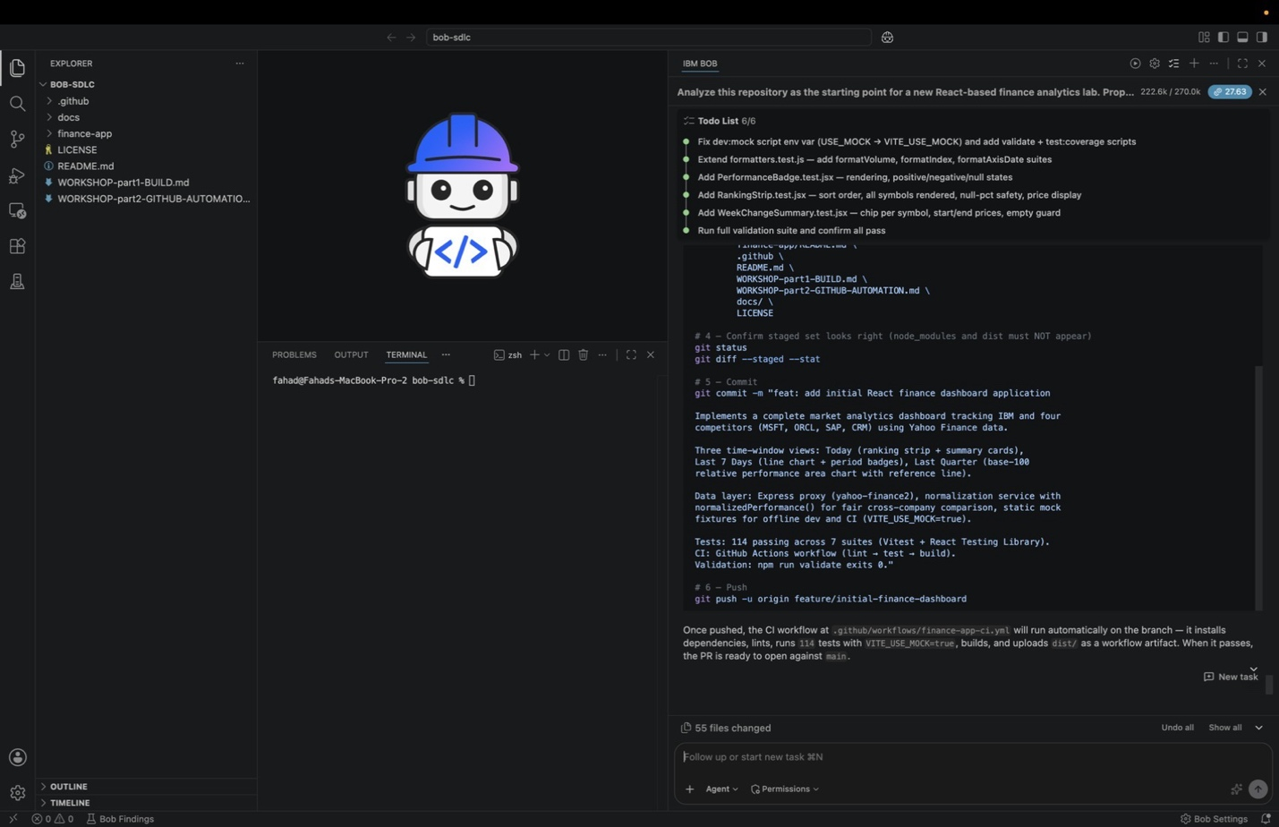
Read the tail of that artifact carefully, because the next steps reuse it:
  - A staging check (git status and git diff --staged --stat) with an explicit reminder that node_modules and dist must not appear in the staged set
  - A commit message in conventional-commit form, for example feat: add initial React finance dashboard application, with a body covering the five tracked companies, the three time-window views, the data layer, the passing test count, and the CI workflow
  - The push command, git push -u origin <branch>
  - A closing note that once the push lands, the CI workflow under .github/workflows/ runs automatically: it installs dependencies, lints, runs the test suite with VITE_USE_MOCK=true, builds, and uploads dist/ as a workflow artifact

- Ask Bob for the delivery artifacts you will use during the push and later on GitHub. Copy and paste the following prompt into the Agentic Sidebar, then hit Enter to execute the instructions:
- Generate a concise summary of the finance dashboard implementation, propose a commit message, and prepare a pull request description that explains the new application, dashboards, and validation steps.
Bob will pause for approval before its first tool call. The command is read-only, a find over finance-app/src that lists the source files so the summary is grounded in what is actually on disk. Click Approve once.
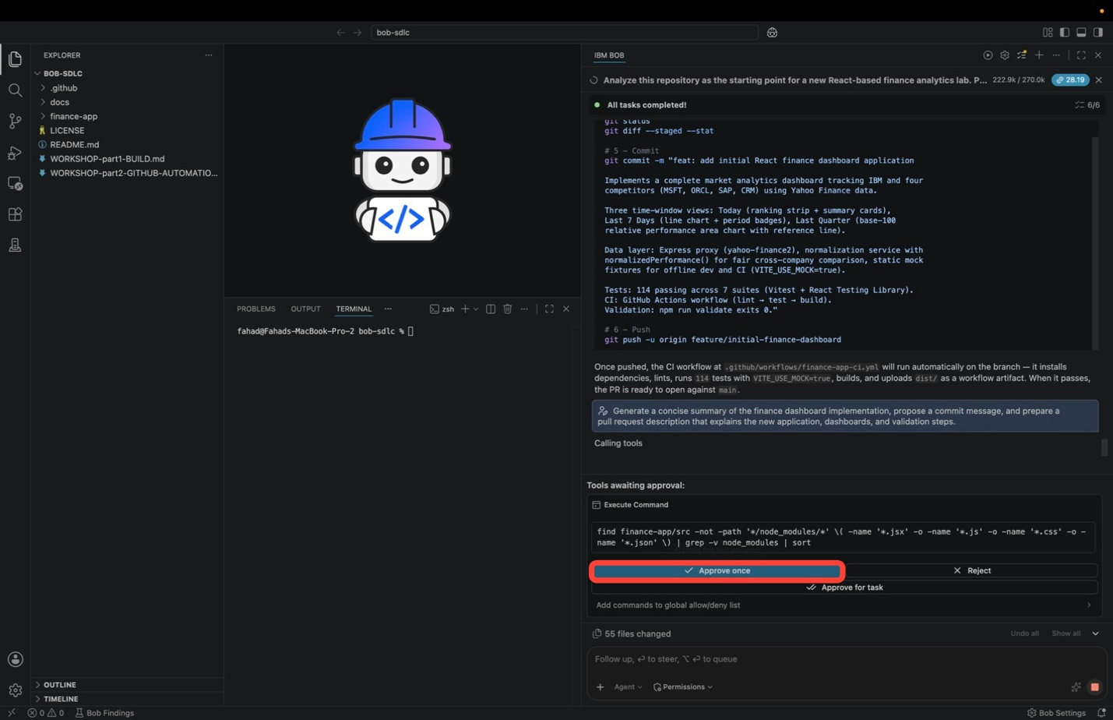
Bob reruns the validation chain, reports Live validation confirmed, and produces the three deliverables as a single self-contained HTML report, the same way it produced the implementation plan in Part 1. Alongside the report, Bob posts a plain-text summary in the sidebar so you can read the essentials without opening anything.
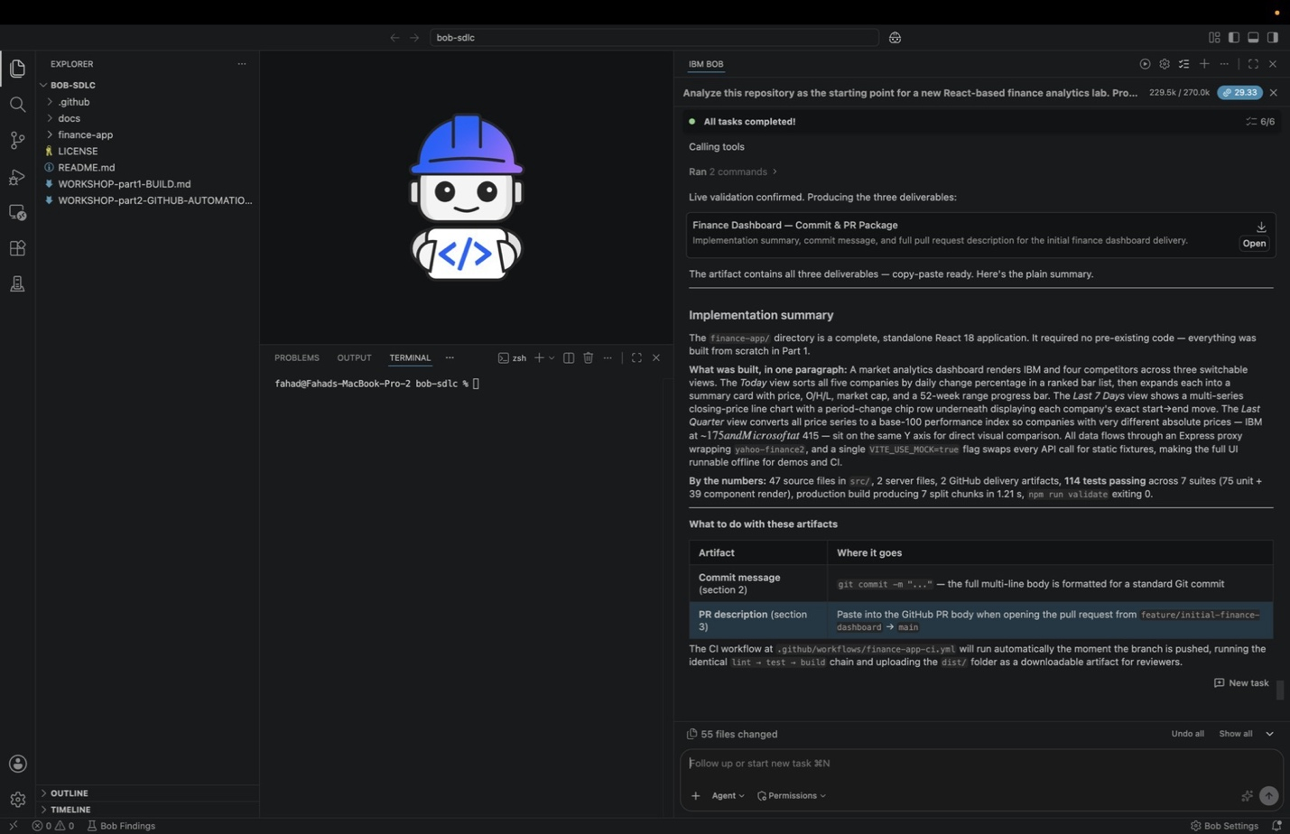
The sidebar summary describes what was built in one paragraph, then quantifies it under By the numbers: 47 source files in src/, 2 server files, 2 GitHub delivery artifacts, 114 tests passing across 7 suites (75 unit plus 39 component render), a production build producing 7 split chunks, and npm run validate exiting 0.
It then tells you where each artifact goes, which is the part that matters for the rest of this module:
ARTIFACT | WHERE IT GOES
Commit message (section 2) | Into git commit -m "...". The full multi-line body is already formatted for a standard git commit
PR description (section 3) | Pasted into the GitHub PR body when the pull request is opened from feature/initial-finance-dashboard into main
Bob also notes that once the branch is pushed, the CI workflow at .github/workflows/finance-app-ci.yml runs the identical lint → test → build chain and uploads the dist/ folder as a downloadable artifact for reviewers.
Now click Open on the Finance Dashboard — Commit & PR Package card to review the full report in the IDE. The report is written to a temporary bob-artifacts/ directory, so open it before starting a new task.
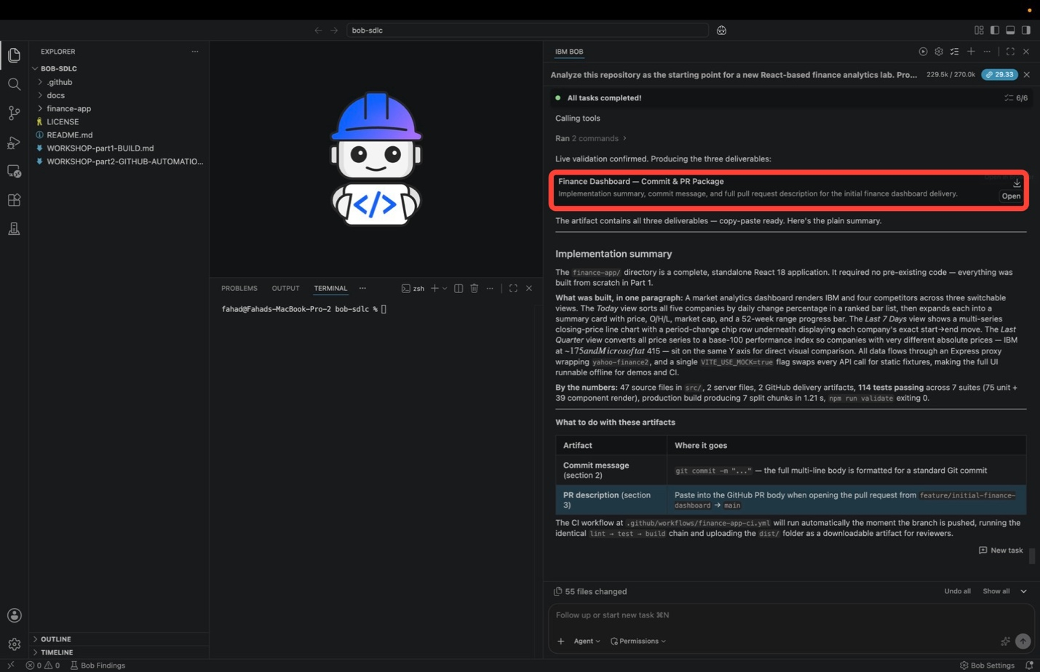
The report opens with a Validation live run panel confirming the three gates Bob just executed against the code on disk: lint reporting 0 errors and 0 warnings, every test in the suite passing, and a clean production build with no warnings. Below the panel, the report is organized into numbered sections.
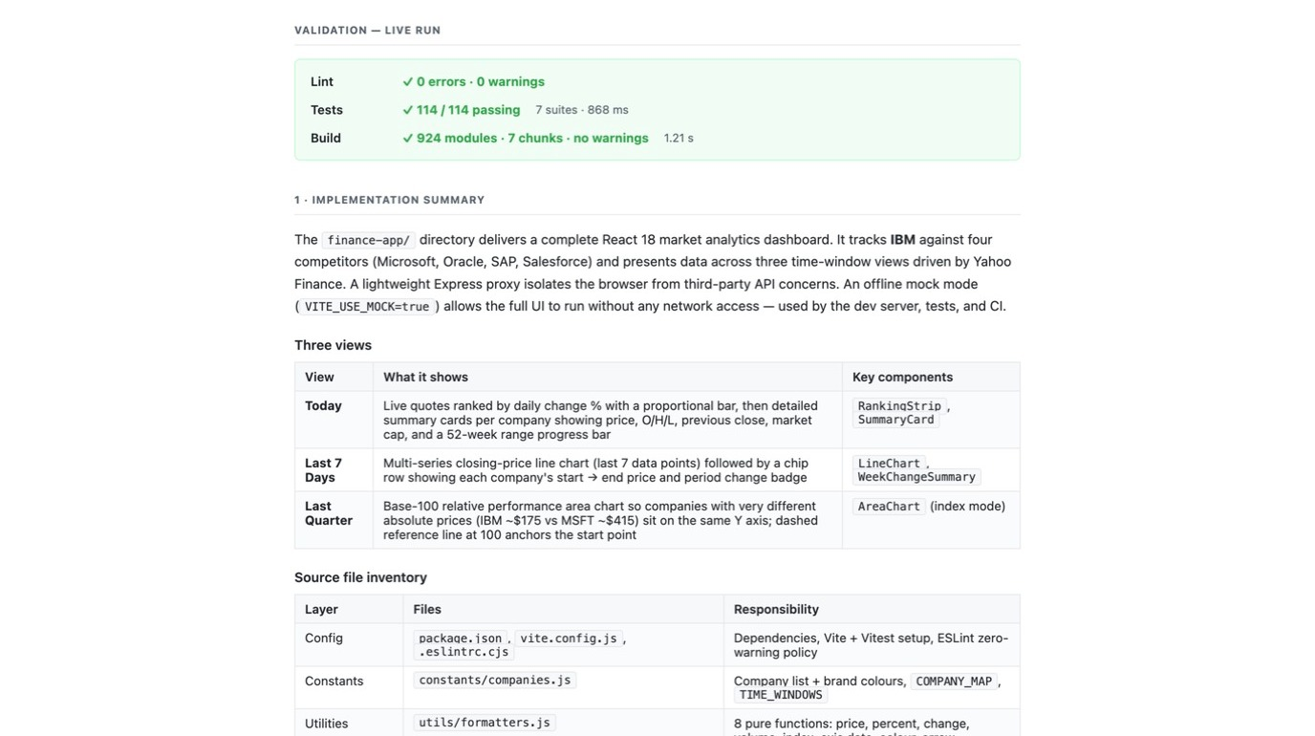
  - 1 · Implementation summary: what the finance-app/ directory delivers — a complete React 18 market analytics dashboard tracking IBM against Microsoft, Oracle, SAP, and Salesforce, with a lightweight Express proxy isolating the browser from third-party API concerns and an offline mock mode (VITE_USE_MOCK=true) that lets the full UI run with no network access, used by the dev server, the tests, and CI.
  - Three views: a table mapping each time window to what it shows and the components that render it — Today (RankingStrip, SummaryCard), Last 7 Days (LineChart, WeekChangeSummary), and Last Quarter (AreaChart in base-100 index mode, so IBM at ~$175 and MSFT at ~$415 sit on the same Y axis).
  - Source file inventory: a layer-by-layer table of config, constants, utilities, data service, state, components, and tests, naming the files in each layer and the responsibility it carries.
  - 2 · Commit message and 3 · Pull request description: the two artifacts you carry forward.
YOUR NUMBERS WILL DIFFER
Those three green results are the substance of the report. The run shown here reports 114 tests across 7 suites, but the exact counts and timings depend on what Part 1 | Build produced on your machine and are not something to match.
Keep both artifacts handy: the commit message is used in Step 7, and the PR description is used when a pull request is opened on GitHub.

- Time to fix the blockers Bob found. Open a new Terminal in the IDE (Terminal → New Terminal) and create the .gitignore at the workspace root, so dependencies and build artifacts never enter version control:
- cat > .gitignore <<'EOF'
- node_modules/
- dist/
- .DS_Store
- .env
- coverage/
- EOF

- You will next need to execute the complete code block after making modifications.
  - Copy and paste the code block below to a notepad for editing
  - Retrieve the GitHub repository remote URL that you recorded earlier in Step 1
  - Substitute the <REMOTE_URL> placeholder token with your repository remote URL
  - Copy and paste the modified code block into the Terminal console and press Enter to execute
- # Initialize the repository
- git init

- # Connect the GitHub remote
- git remote add origin <REMOTE_URL>

- # Verify the remote was added
- git remote -v

- Stage, commit, name the default branch, and finally push it. Use the commit message Bob proposed in Step 4.
  - Copy and paste the code block below to a notepad for editing
  - Retrieve the commit message that IBM Bob recommended earlier in Step 4
  - Substitute the <COMMIT_MESSAGE> placeholder token with the message from Step 4
  - Copy and paste the modified code block into the Terminal console and press Enter to execute
- # Stage everything
- git add .

- # IMPORTANT: confirm node_modules and dist do NOT appear in the staged list
- git status

- # Commit using the message Bob proposed
- git commit -m "<COMMIT_MESSAGE>"

- # Name the default branch main
- git branch -M main

- # Push to GitHub
- git push -u origin main
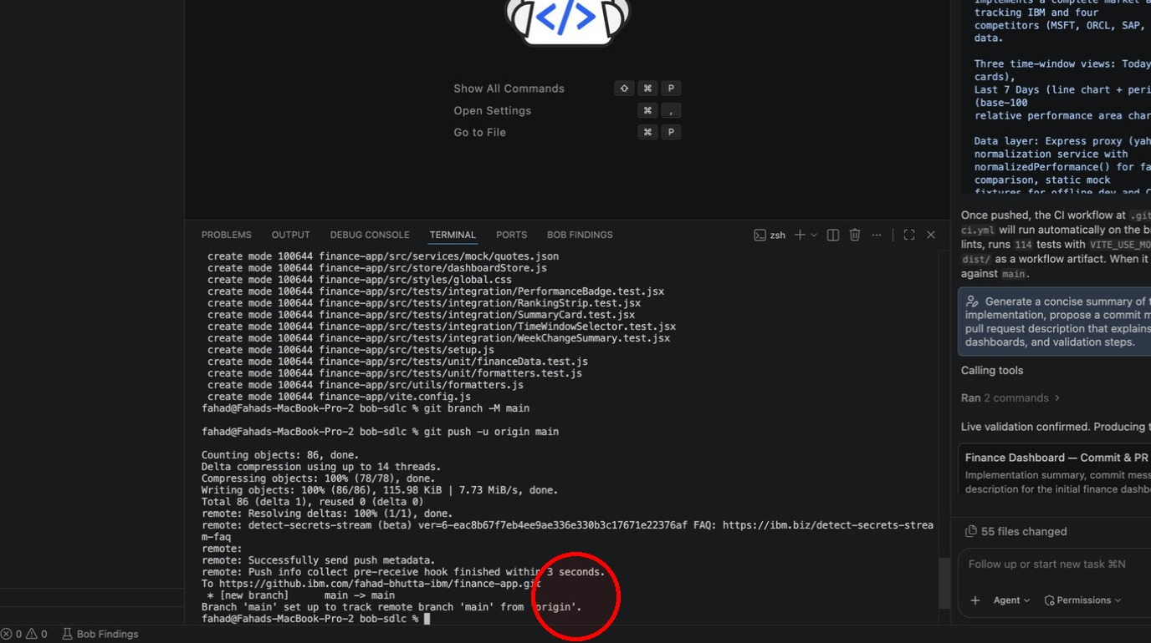
The commit output lists every file as create mode 100644 ..., so read it and confirm that only source files are being tracked. The push output then reports the objects written and ends with the two lines that confirm the publish succeeded:
* [new branch] main -> main
Branch 'main' set up to track remote branch 'main' from 'origin'.
RENAME THE BRANCH AFTER THE FIRST COMMIT
git branch -M main renames the branch you are currently on. Immediately after git init there are no commits yet, so that branch does not exist as a reference and the rename fails with error: refname refs/heads/master not found. Git 2.30 and later handle this case, but older versions do not, so this workshop renames the branch after the commit. This is also the order GitHub's own Quick setup page uses.
If you have already hit the error, either commit first and then rerun git branch -M main, or point HEAD at the branch directly with git symbolic-ref HEAD refs/heads/main.
TROUBLESHOOTING: AUTHENTICATION ISSUES
GitHub no longer accepts account passwords over HTTPS. If the push prompts for credentials, use a Personal Access Token (PAT) in place of the password, or configure SSH keys and use the SSH remote URL instead. See GitHub's authentication documentation for both paths.
If the push is rejected, confirm you have write access to the repository, check that no branch protection rule is blocking the push, and verify the remote URL with git remote -v.

- Verify the published repository in your browser. Refresh the repository page on GitHub.com and confirm:
  - All files from Part 1 are visible: the application source, the docs, and the PR template
  - node_modules/ and dist/ are not in the file tree
  - The Finance App CI workflow is listed under the Actions tab
  - The pull request template is visible at .github/PULL_REQUEST_TEMPLATE.md
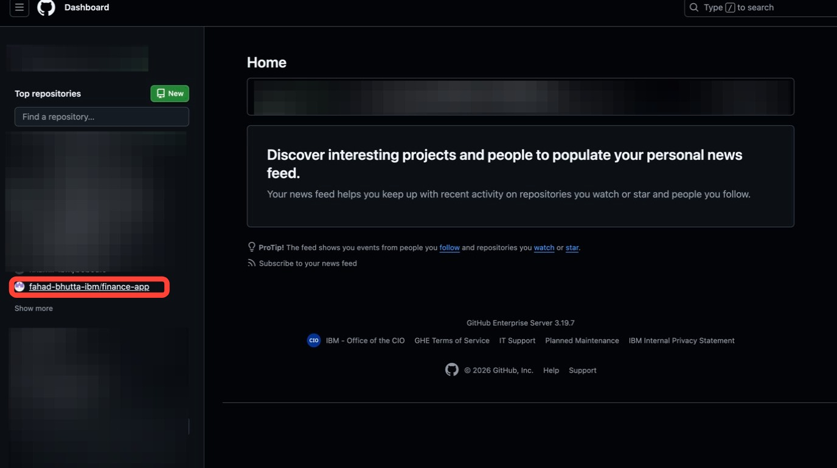
Open the repository from your GitHub dashboard.
  - The repository home page should show a single commit carrying Bob's commit message, on one branch, with the root file tree: .github/, docs/, finance-app/, .gitignore, LICENSE, README.md, and the workshop markdown files.
  - Confirm that node_modules/ and dist/ are not included within that list (the .gitignore you created in Step 5 is what kept them out)
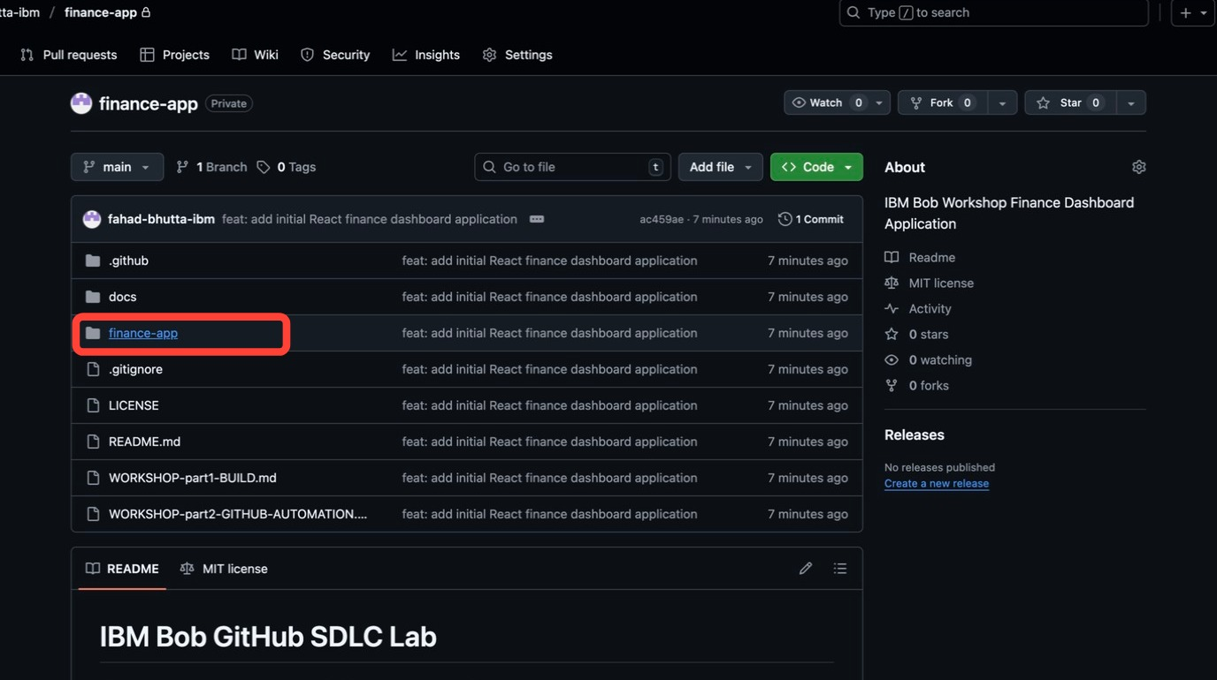
Click into finance-app/ and check the application directory the same way. You should see public/, server/, src/, and the config files (.eslintrc.cjs, index.html, package.json, package-lock.json, vite.config.js), with no node_modules/ and no dist/.
Note that package-lock.json is committed, which is what lets CI run a reproducible npm ci.
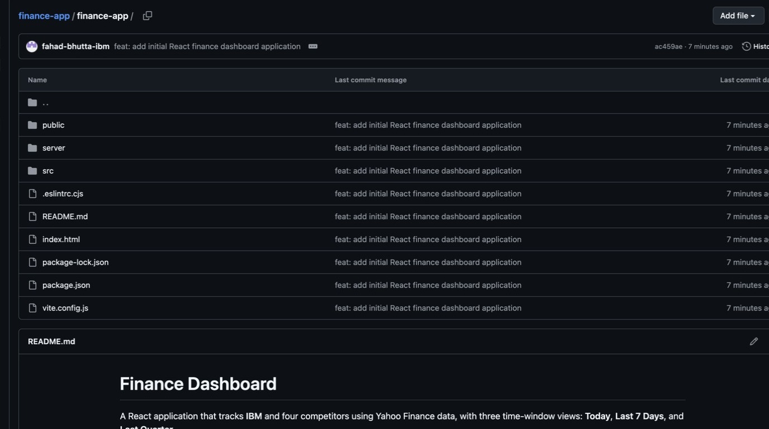
NO WORKFLOW RUNS YET — AND THAT IS EXPECTED
The Actions tab will list Finance App CI in the left sidebar but report There are no workflow runs yet. GitHub detects the workflow by parsing .github/workflows/finance-app-ci.yml on the default branch; detecting it is not the same as running it.
The workflow is deliberately scoped to the delivery paths that matter, and a direct push to main is not one of them:
on:
push:
branches:
- 'feature/**'
- 'fix/**'
- 'chore/**'
pull_request:
branches:
- main
The first run arrives in Step 9, when the feature/initial-finance-dashboard branch is pushed and matches feature/**.
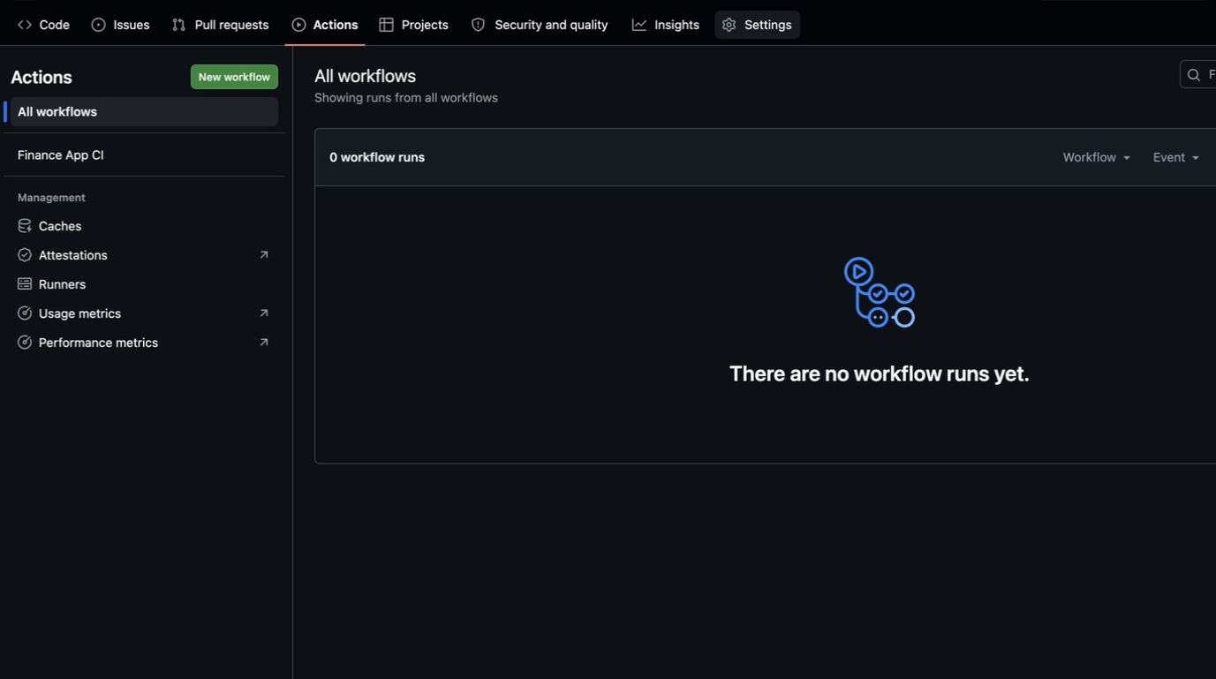
Then go to Settings → General and scroll to the Features section. - Confirm the Issues checkbox is ticked, since the feature request workflow in the next module depends on it. - Leave Issue permissions on the default, Creation allowed by: All users.
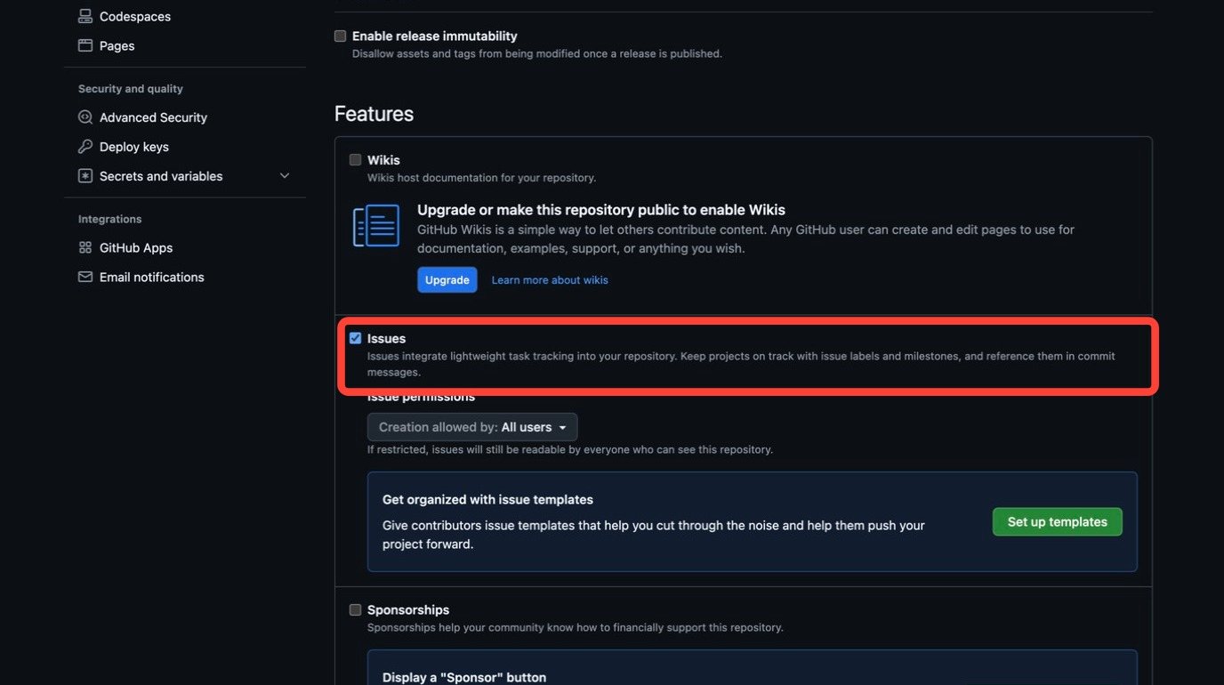

- Create the feature branch for the workshop. Feature work never lands on main directly; it travels on its own branch and arrives through a pull request. Back in the IDE terminal:
- # Create and switch to a new feature branch
- git checkout -b feature/initial-finance-dashboard

- # Push the branch to GitHub
- git push -u origin feature/initial-finance-dashboard
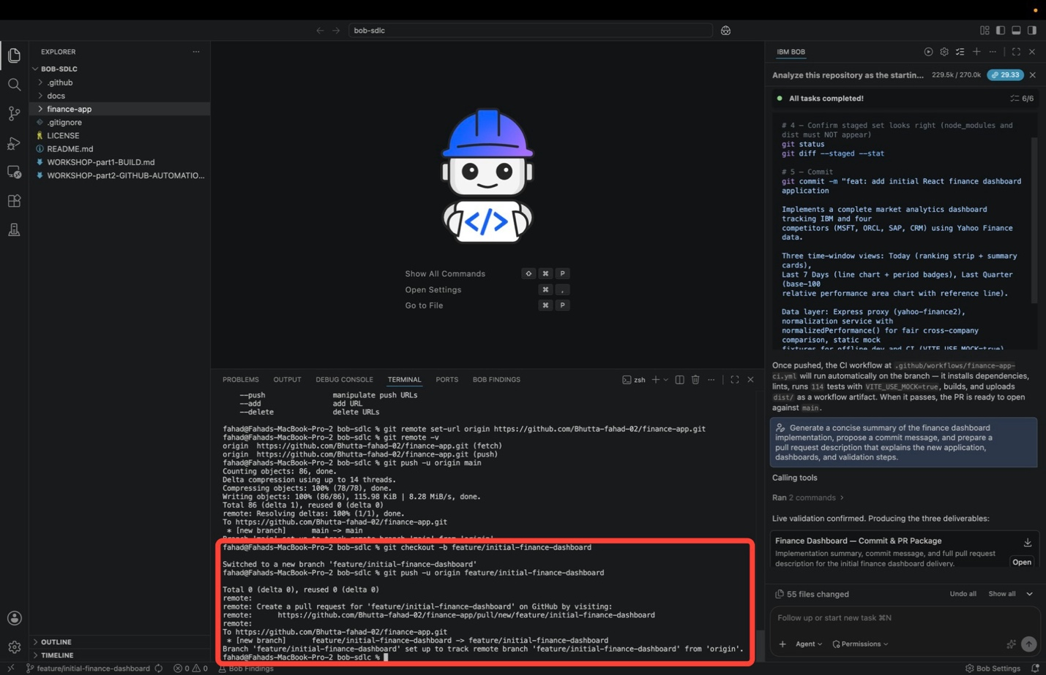
The terminal confirms the switch with Switched to a new branch 'feature/initial-finance-dashboard'. At that point the branch exists only locally; the git push that follows is what publishes it.
This push is what starts CI. The branch name matches the feature/** pattern in the workflow trigger, so return to the repository on GitHub and click the Actions tab. The repository header should now read 2 Branches.
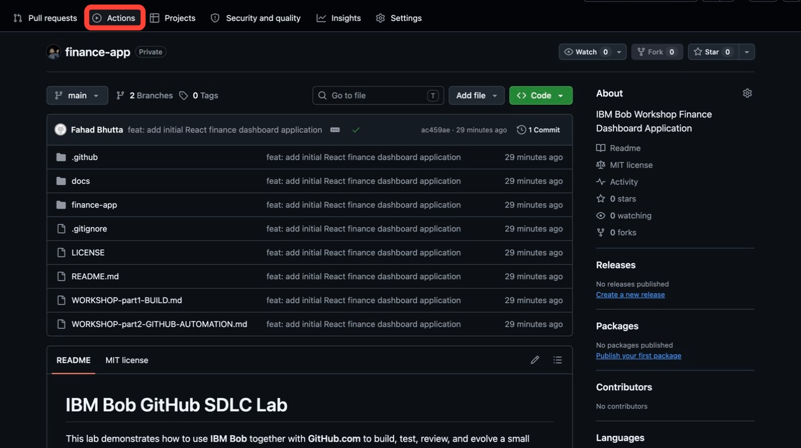
Where the Actions tab reported no runs in Step 8, it now shows 1 workflow run, titled with your commit message and labelled Finance App CI #1, with the commit hash, your username, and the feature/initial-finance-dashboard branch it ran against.
Click the run to open it.
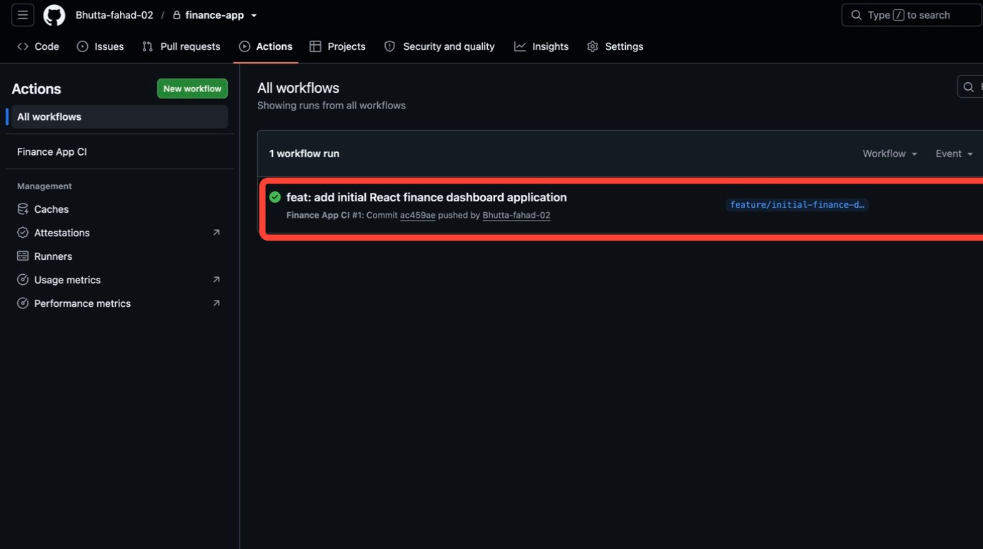
The run summary is what this entire module has been building toward. Confirm:
  - Triggered via push on feature/initial-finance-dashboard, with Status: Success
  - The single Lint → Test → Build job carrying a green check, completing in well under a minute
  - Artifacts: 1, listing finance-app-dist, the built dist/ folder uploaded by the workflow's final step and downloadable by any reviewer
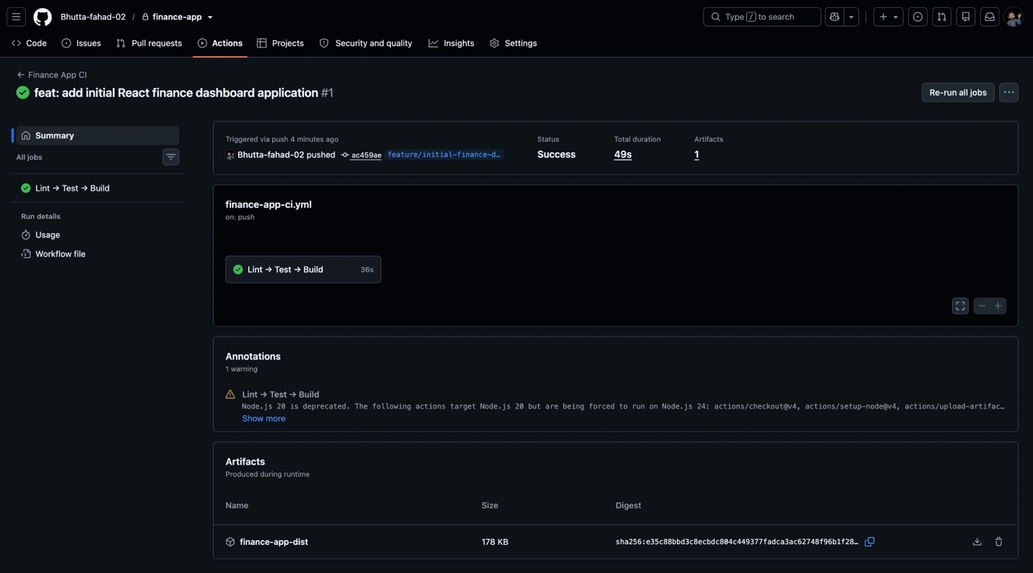
The same gates Bob ran locally in Step 3 and Step 4 have now run on a clean machine, against the code as GitHub received it. That is the point of pushing to a branch first: the validation is no longer taking your word for it.
AN ANNOTATION WARNING IS NOT A FAILURE
The run may show Annotations: 1 warning reporting that Node.js 20 is deprecated and that actions/checkout, actions/setup-node, and actions/upload-artifact are being forced onto a newer Node.js runtime. This is GitHub deprecating the runtime its own actions run on rather than a problem with the finance dashboard. The job status is still Success, and the workshop continues unchanged.
BRANCH NAMING CONVENTIONS
A consistent branch naming convention keeps AI assisted work traceable alongside human work. This workshop uses the pattern most teams will recognize:
  - feature/initial-finance-dashboard (created just now, the published baseline)
  - feature/user-selected-company-chart (created in the next module, carries the enhancement)
  - fix/chart-data-normalization (the shape a future bug fix would take)

- Finally, open the issue that drives the next module. Click the Issues tab in the repository header, then click New issue.
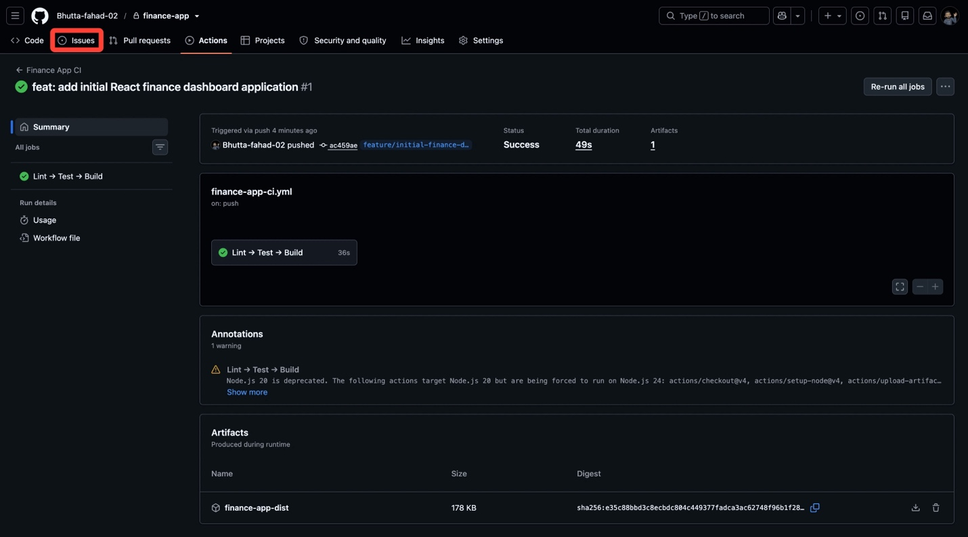
On the Create new issue form, fill in:
  - Add a title: Add a graph for a user selected company
  - Add a description:
Add a new graph based on a company indicated by the user.

* Allow the dashboard to accept a stock symbol or company selection
* Render an additional comparison chart for the selected company
* Invalid or unsupported symbols should produce a clear message to the user
* The existing dashboards for IBM and its competitors must remain unchanged
WHY IS THE BODY WRITTEN THIS WAY?
The description is deliberately written as an outcome plus four constraints rather than as a set of implementation instructions. It says what the user should be able to do, what must appear, how failure should behave, and what must not regress. That is enough for Bob to plan against, and it leaves the design decisions where they belong. Notice that the last bullet is a guard: it tells Bob what success must not break.
  - Leave Assignees, Labels, Projects, and Milestone empty (Bob reads the title and body, and nothing else here changes what it does in the next module)
  - When ready to continue, click Create
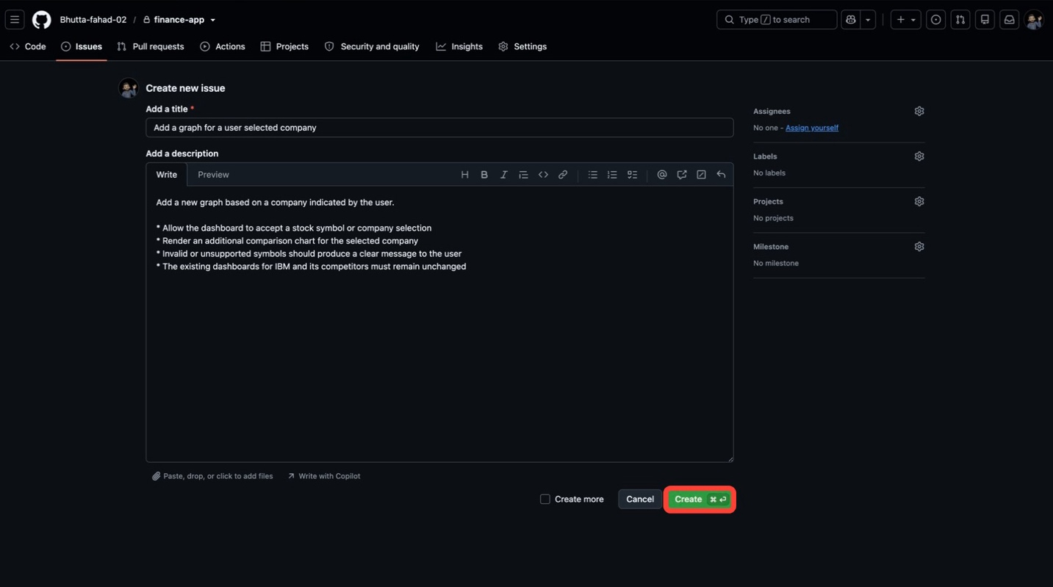
Note the issue number GitHub assigns (typically #1). Bob will fetch this issue by number in the next module.

iii. Verification checklist
Before moving on, confirm every row. The next two modules assume all of this is in place:
CHECK | WHAT TO CONFIRM
GitHub repository created and accessible | Repository page loads at github.com/YOUR_USERNAME/finance-app
.gitignore in place | node_modules/ and dist/ absent from the GitHub file tree
Local git repository initialized | git status reports a branch, not an error
Local repository connected to the GitHub remote | git remote -v shows origin
Code pushed to GitHub successfully | Part 1 Build files visible on the main branch
CI workflow detected | Actions tab lists Finance App CI, with no runs until the feature branch is pushed
Issues and Pull Requests enabled | Settings → General → Features
Feature branch created and pushed | feature/initial-finance-dashboard visible on GitHub
CI run green | Actions shows a passing Finance App CI run for the feature branch
Enhancement issue created | Issue #1 open in the Issues tab

iv. Key takeaways
- Publishing happens in a fixed order: create the empty GitHub repository, let Bob confirm readiness, initialize the local repository, then push. Each step depends on the one before it.
- Bob catches delivery blockers a developer might miss, like a missing .gitignore that would commit thousands of dependency files, and prepares the exact commands to fix them.
- The developer performs the push. Bob prepares the delivery, but the repository remains under your control.
- Feature work travels on branches, never directly on main. The baseline branch exists now, and the enhancement gets its own branch in the next module.
- An issue is the entry point of the evolution loop. The next module starts from issue #1 rather than from a prompt written from scratch.
The next module is the central demonstration of the lab. In Implementing a Feature Request, Bob will fetch the issue you just created, analyze the requested scope, implement the new company chart, and validate the result.

Previous
1.2 Building and validating the dashboards

Next
2.2 Implementing a feature request

Copyright © 2026
Made with Material for MkDocs

